**Entrepreneurship important questions:**

**Short answer questions:**

1. What are the elements affecting new venture?

Market Demand, Business Plan, Capital, Competition, Legal Environment, Economic Conditions, Technology, Management Team, Marketing and Sales Strategy, **Customer Relationships, Supply Chain Management.**

1. Define start-up methodology.

Start-up methodology involves structured approaches for developing and scaling new businesses. It includes frameworks like Lean Startup, which emphasizes iterative product development and customer feedback, and Agile, which focuses on flexibility and rapid prototyping to quickly adapt to market needs and optimize product-market fit.

1. Define WIPO.

The World Intellectual Property Organization (WIPO) is a specialized agency of the United Nations dedicated to promoting and protecting intellectual property (IP) worldwide. It provides a global forum for IP services, policy, information, and cooperation, helping to ensure that IP rights are respected and managed effectively across countries.

1. Why IPR is important?

Intellectual Property Rights (IPR) are crucial as they protect innovations, encouraging creativity and investment in research and development. They foster economic growth by promoting fair competition and preventing counterfeiting. IPR also ensures consumer protection and supports cultural development by safeguarding artistic works. Additionally, strong IPR laws attract international trade and provide financial rewards to creators.

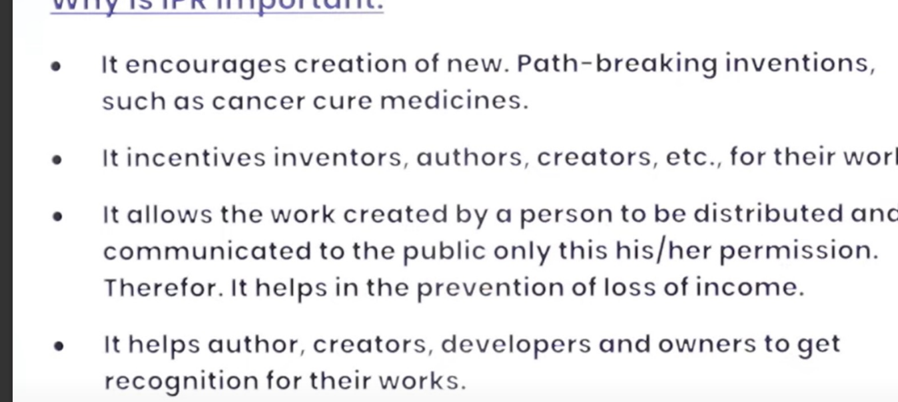

1. What are the types of Trademarks?

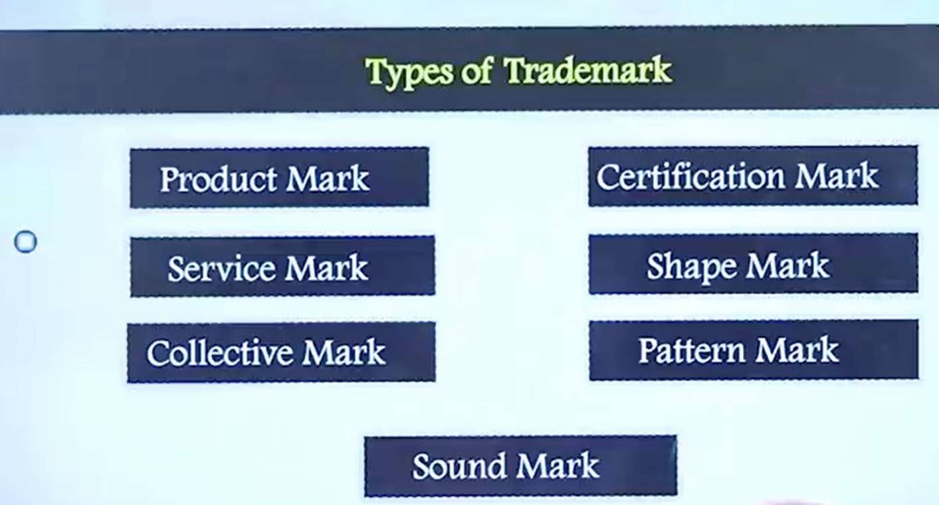

1. What are the challenges of new venture start-ups?

New venture start-ups face numerous challenges, including:

1. **Funding**: Securing sufficient capital to launch and sustain the business.

2. **Market Entry**: Overcoming competition and establishing a presence in the market.

3. **Resource Management**: Efficiently managing limited resources such as time, money, and personnel.

4. **Business Model**: Developing a viable and scalable business model.

5. **Regulatory Compliance**: Navigating legal and regulatory requirements specific to their industry.

6. **Customer Acquisition**: Attracting and retaining customers in a competitive landscape.

7. **Operational Efficiency**: Setting up effective processes and systems to manage operations smoothly.

8. **Team Building**: Recruiting, retaining, and managing a skilled and motivated team.

9. **Technology Adoption**: Implementing and keeping up with relevant technologies.

10. **Risk Management**: Identifying and mitigating potential risks and uncertainties.

These challenges require careful planning, adaptability, and strategic thinking to overcome and achieve long-term success.

1. What are the key elements of strategic positioning?

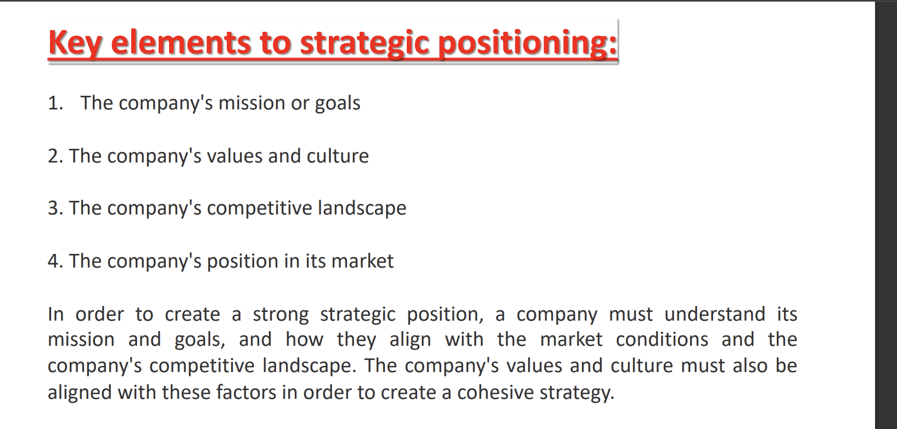

1. What is strategic perspective?

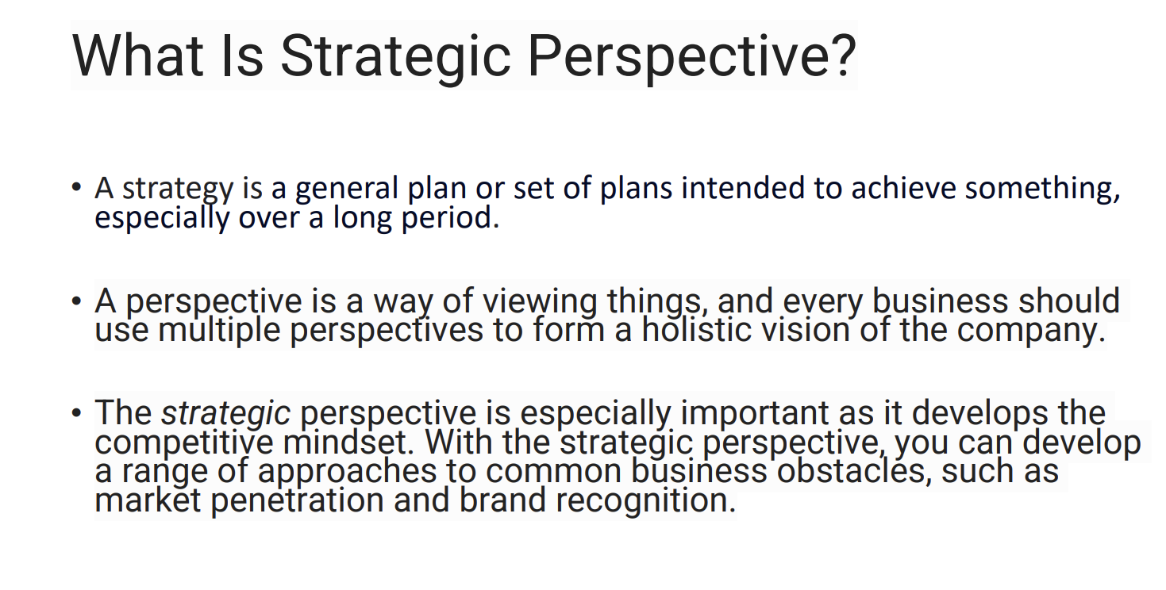

A strategic perspective involves a long-term, big-picture approach to planning and decision-making. It includes defining a clear vision and setting long-term goals, analyzing external market trends and internal capabilities, and ensuring alignment of activities with the organization's objectives. It also emphasizes flexibility and responsiveness to changing circumstances. This approach helps organizations navigate complexities and maintain a competitive edge.

1. Define SWOT Analysis.

SWOT Analysis is a strategic planning tool used to identify and evaluate the internal and external factors affecting an organization. It stands for:

1. **Strengths**: Internal attributes and resources that support achieving objectives.

2. **Weaknesses**: Internal limitations or areas needing improvement.

3. **Opportunities**: External factors or trends that the organization can capitalize on.

4. **Threats**: External challenges or risks that could hinder achieving objectives.

SWOT Analysis helps organizations develop strategies by understanding their strengths, addressing weaknesses, seizing opportunities, and mitigating threats.

1. What are the components of strategic entrepreneurship?

Strategic entrepreneurship combines entrepreneurial actions with a strategic perspective to drive innovation, competitive advantage, and growth. The key components include:

1. **Opportunity Recognition**: Identifying and exploiting new market opportunities.

2. **Innovation**: Developing new products, services, processes, or business models.

3. **Risk Management**: Assessing and mitigating risks associated with entrepreneurial activities.

4. **Resource Leveraging**: Efficiently utilizing and acquiring resources to maximize potential.

5. **Strategic Flexibility**: Adapting to changing market conditions and external environments.

6. **Competitive Advantage**: Establishing and maintaining a unique position in the market.

7. **Vision and Leadership**: Guiding the organization with a clear vision and strong leadership to achieve long-term goals.

These components work together to create value and drive the sustainable success of the organization.

1. What is hybrid franchising?

Hybrid franchising combines elements of traditional franchising with added flexibility, such as a mix of company-owned and franchisee-owned units, allowing for local market adaptation. It enhances innovation and collaboration by providing extensive support and resources while sharing risks and rewards. This model enables faster market expansion and stronger brand consistency but requires careful management to balance customization with uniform standards. Despite its complexity, hybrid franchising offers a versatile and innovative approach to business growth.

1. What is the difference between business incubator and seed accelerator?

Business incubators and seed accelerators both support early-stage startups, but they differ in structure, focus, and the type of assistance they provide.

1. **Duration and Program Structure:**

- **Business Incubator:** Typically offers long-term support, ranging from months to years, focusing on nurturing startups through their early stages of development.

- **Seed Accelerator:** Provides a fixed-term, intensive program, usually lasting a few months, designed to accelerate growth and prepare startups for investment.

2. **Support and Resources:**

- **Business Incubator:** Offers a wide range of resources, including office space, mentorship, administrative support, and access to networks. The support is often more customized to the specific needs of each startup.

- **Seed Accelerator:** Provides a structured program with mentorship, funding, and educational components, culminating in a demo day where startups pitch to investors. The support is more standardized and focused on rapid growth.

3. **Funding:**

- **Business Incubator:** May offer limited or no direct funding, focusing more on providing resources and support services.

- **Seed Accelerator:** Typically provides seed funding in exchange for equity, helping startups with initial capital to grow quickly.

4. **Selection Process:**

- **Business Incubator:** Often has a more flexible and ongoing selection process, accepting startups at various stages of development.

- **Seed Accelerator:** Usually has a competitive, cohort-based selection process, with startups joining and graduating the program together.

5. **End Goals:**

- **Business Incubator:** Aims to support sustainable growth and long-term development, helping startups build a solid foundation.

- **Seed Accelerator:** Focuses on preparing startups for investment and rapid scaling, with the goal of securing follow-on funding or achieving significant growth quickly.

In summary, while both incubators and accelerators help early-stage startups, incubators provide long-term, customized support for sustainable growth, whereas accelerators offer short-term, intensive programs aimed at rapid development and investment readiness.

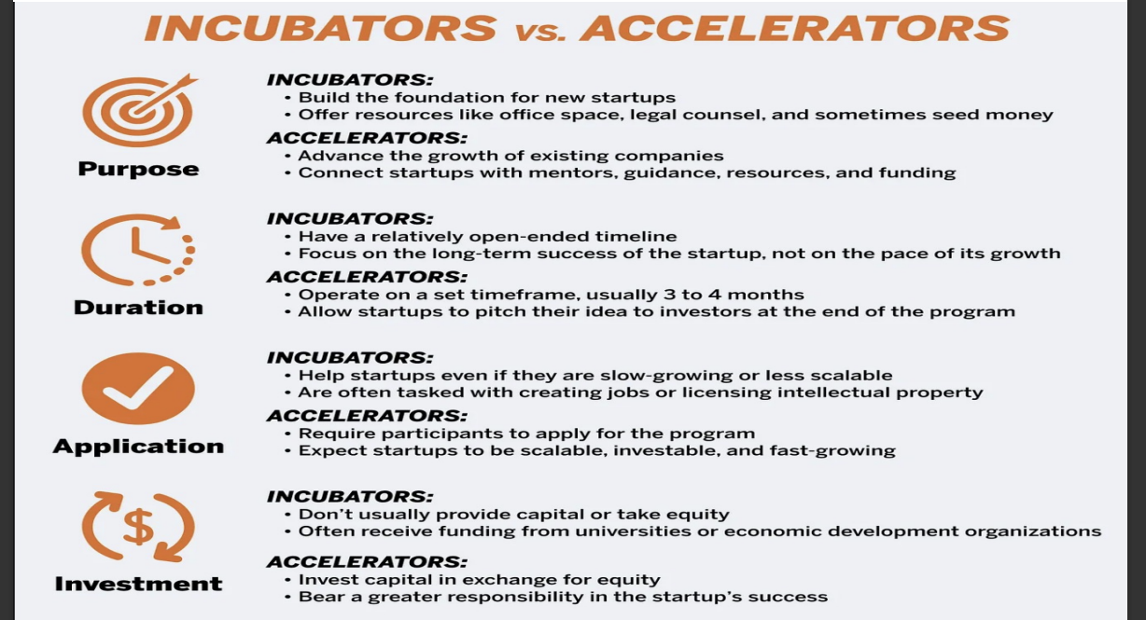

1. How to avoid Trademark Pitfalls?

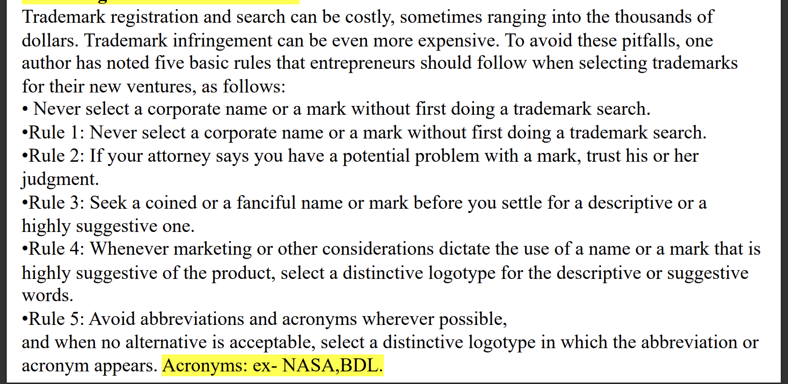

1. What are the critical factors for new venture development?

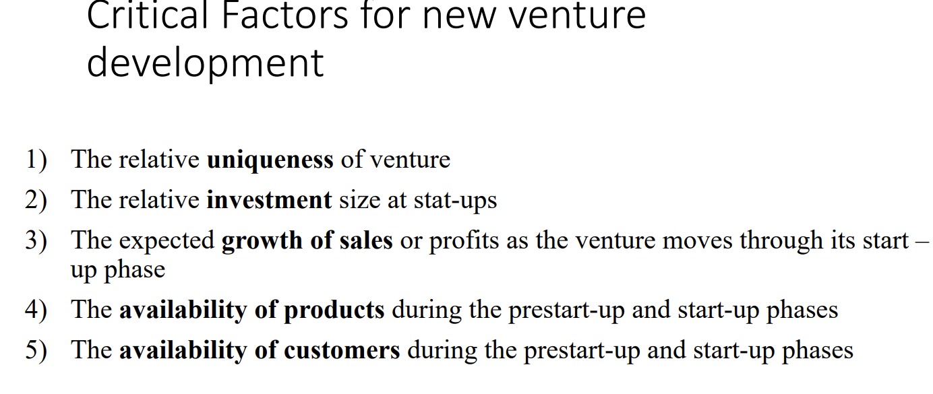

1. What is financial feasibility approach?

Financial feasibility approach involves assessing revenue projections, estimating costs, analyzing profitability and cash flow, conducting break-even analysis, and evaluating financial ratios to determine the economic viability and sustainability of a business idea or project. It helps stakeholders make informed decisions, manage risks, allocate resources effectively, and plan for long-term financial success.

1. What are the types of business firms?

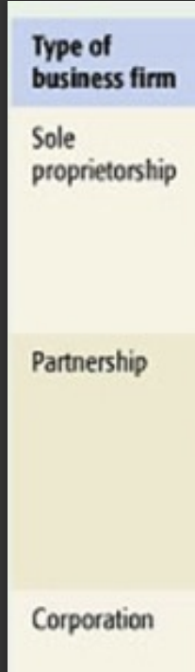

1. How to build a strategic action plan in entrepreneurship?

Building a strategic action plan in entrepreneurship involves several key steps to ensure clarity, alignment with business goals, and effective implementation. Here’s a concise outline in 5 lines:

1. **Set Clear Objectives:** Define specific, measurable goals aligned with your business vision and mission.

2. **Conduct Market Research:** Understand your target market, competitors, and industry trends to inform strategic decisions.

3. **Develop Strategies:** Identify key strategies and tactics to achieve your objectives, considering factors like marketing, operations, and financial management.

4. **Create Actionable Steps:** Break down strategies into actionable steps with clear timelines, responsibilities, and resources required.

5. **Monitor and Adapt:** Continuously monitor progress, assess outcomes, and adapt strategies as needed to stay agile and responsive to changing market conditions.

1. What are the approaches to strategy formulation?

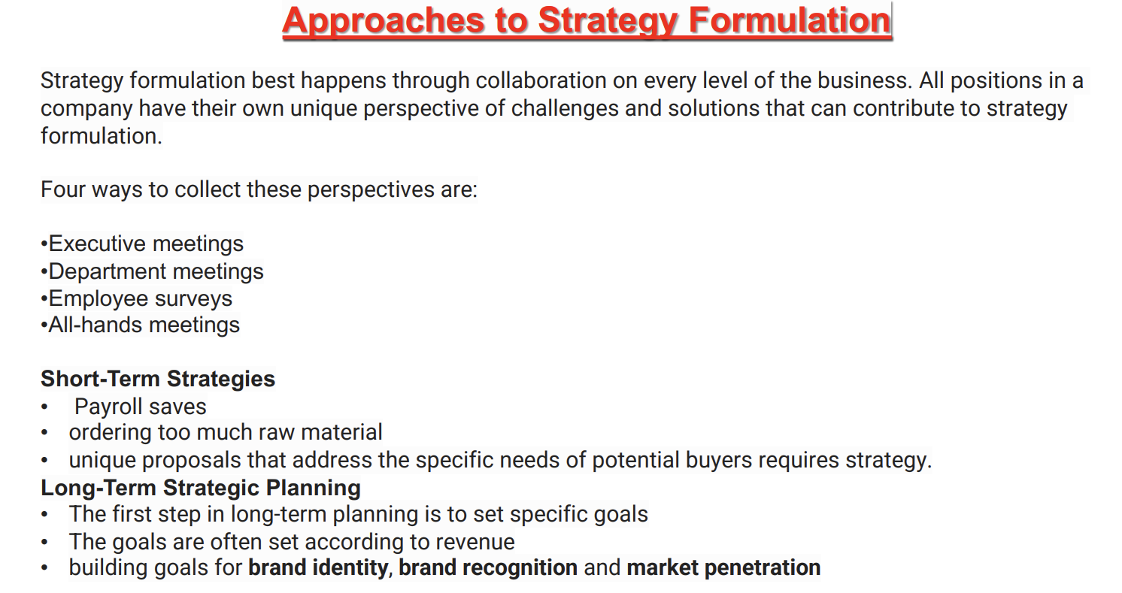

1. What are the 4P's of Strategic planning?

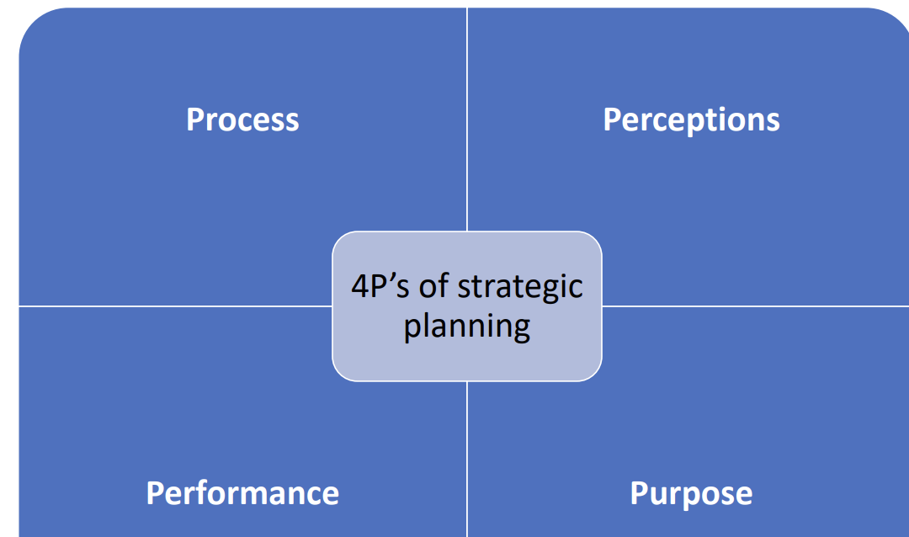

1. How to build the adaptive firm?

Building an adaptive firm involves fostering a culture of continuous learning and agility, empowering decision-making at all levels, maintaining strategic flexibility in operations and customer relations, fostering collaborations, and proactive risk management. This approach ensures readiness to navigate uncertainties, capitalize on opportunities, and sustain long-term growth in dynamic market environments.

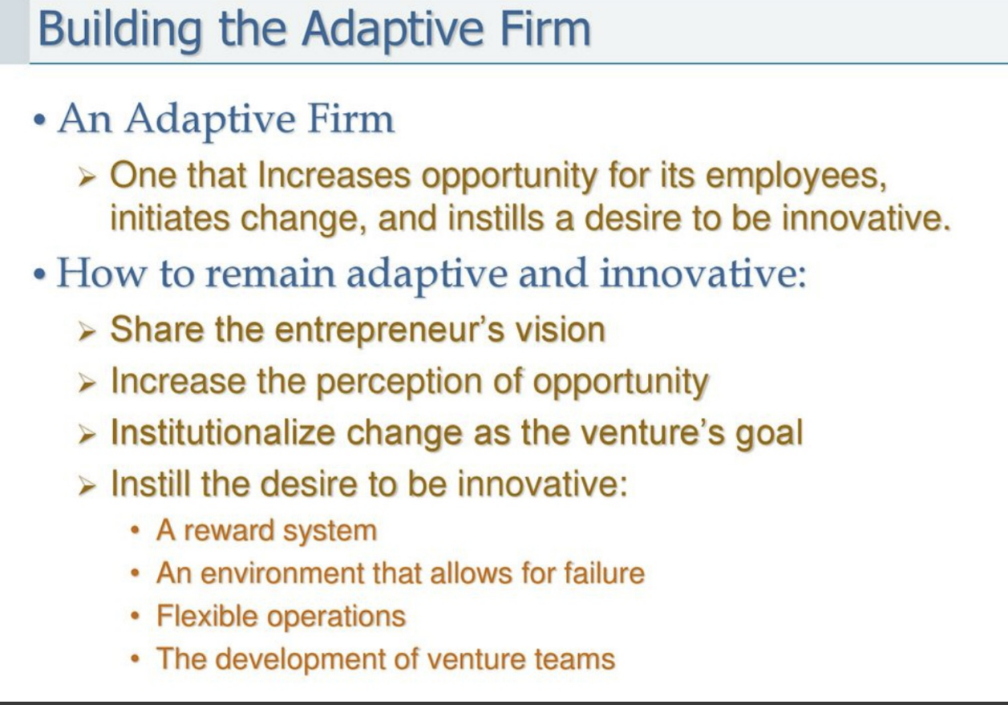

**Long answer questions**:

1. Explain the methods to initiate entrepreneurial venture.3

Initiating an entrepreneurial venture involves several steps, from ideation to execution. Here's a comprehensive guide to help you get started:

### 1. Self-Assessment

- **Skills and Interests**: Assess your skills, interests, and passions. This will help you choose a venture that aligns with your strengths and passions.

- **Risk Tolerance**: Evaluate your risk tolerance and financial situation. Understand that entrepreneurship involves significant risks.

### 2. Idea Generation

- **Identify Problems**: Look for problems or gaps in the market that need solutions.

- **Brainstorm Solutions**: Come up with innovative solutions to these problems.

- **Market Research**: Conduct market research to validate your idea. Determine if there is a demand for your product or service.

### 3. Business Plan

- **Executive Summary**: Write a brief overview of your business idea.

- **Business Description**: Describe your business in detail, including what it will offer and how it will operate.

- **Market Analysis**: Provide an analysis of your target market, including size, demographics, and key trends.

- **Competitive Analysis**: Identify your competitors and analyze their strengths and weaknesses.

- **Marketing Strategy**: Outline how you will attract and retain customers.

- **Operations Plan**: Describe your business operations, including production, location, and supply chain.

- **Financial Plan**: Include financial projections, such as startup costs, revenue, profit margins, and break-even analysis.

### 4. Legal Considerations

- **Business Structure**: Choose a legal structure for your business (e.g., sole proprietorship, partnership, LLC, corporation).

- **Registration**: Register your business name and obtain any necessary licenses and permits.

- **Tax Identification**: Apply for an Employer Identification Number (EIN) if required.

- **Legal Documentation**: Draft important documents such as contracts, agreements, and terms of service.

### 5. Funding

- **Personal Savings**: Use your own savings to fund the startup.

- **Friends and Family**: Seek investments from friends and family.

- **Loans**: Apply for business loans from banks or other financial institutions.

- **Investors**: Pitch your idea to angel investors or venture capitalists.

- **Crowdfunding**: Use crowdfunding platforms to raise funds from the public.

### 6. Build Your Team

- **Hiring**: Identify key roles and hire employees or contractors as needed.

- **Advisors and Mentors**: Seek guidance from experienced entrepreneurs and industry experts.

### 7. Develop Your Product or Service

- **Prototype**: Develop a prototype of your product or a minimum viable product (MVP) for your service.

- **Testing**: Test your product or service with a small group of users to gather feedback and make improvements.

- **Iteration**: Refine your product or service based on user feedback.

### 8. Marketing and Launch

- **Branding**: Develop your brand identity, including name, logo, and messaging.

- **Online Presence**: Create a website and establish a presence on social media platforms.

- **Marketing Campaigns**: Launch marketing campaigns to create awareness and attract customers.

- **Launch Event**: Plan a launch event to introduce your product or service to the market.

### 9. Operations and Scaling

- **Daily Operations**: Set up systems and processes for day-to-day operations.

- **Customer Service**: Provide excellent customer service to build a loyal customer base.

- **Feedback Loop**: Continuously gather feedback from customers and make improvements.

- **Scaling**: Plan for scaling your business by expanding your product line, entering new markets, or increasing production capacity.

### 10. Monitor and Adjust

- **Performance Metrics**: Track key performance indicators (KPIs) to measure your business's success.

- **Financial Management**: Keep a close eye on your finances, including cash flow, expenses, and profits.

- **Adaptability**: Be prepared to pivot or make adjustments based on market trends and business performance.

Starting an entrepreneurial venture requires careful planning, dedication, and perseverance. By following these steps, you can increase your chances of building a successful business.

1. How franchising works an33d write about advantages and disadvantages of franchising?3

### How Franchising Works

Franchising is a method of expanding a business and distributing goods and services through a licensing relationship. In a franchise relationship, the franchisor (the owner of the franchise) grants the franchisee (the buyer of the franchise) the right to use its trademark, brand name, business systems, and processes to sell its products or services.

**Steps Involved in Franchising:**

1. **Initial Contact:** Prospective franchisees contact the franchisor to express interest. The franchisor provides information about the franchise opportunity.

2. **Application and Evaluation:** The prospective franchisee completes an application form. The franchisor evaluates the applicant's background, financial status, and business acumen.

3. **Disclosure:** The franchisor provides a Franchise Disclosure Document (FDD), which contains detailed information about the franchise, including fees, initial investment, and obligations.

4. **Agreement:** If both parties agree to proceed, they sign a franchise agreement. This legally binding document outlines the terms and conditions of the franchise relationship.

5. **Training:** The franchisor provides comprehensive training to the franchisee and their staff. This includes operational procedures, marketing, and customer service.

6. **Setup:** The franchisee sets up the new business location, often with the franchisor's assistance. This includes securing a lease, fitting out the premises, and sourcing initial inventory.

7. **Launch:** The franchisee opens the new franchise location, usually with support from the franchisor in terms of marketing and initial operations.

8. **Ongoing Support:** The franchisor provides ongoing support to the franchisee, including training, marketing, product development, and operational assistance.

### Advantages of Franchising

1. **Brand Recognition:** Franchisees benefit from the established brand and reputation of the franchisor, which can attract customers more easily than starting a new, unknown business.

2. **Proven Business Model:** Franchisees oper ate under a proven business model, reducing the risk of failure compared to starting an independent business.

3. **Training and Support:** Franchisors provide initial and ongoing training and support, helping franchisees understand and implement business operations effectively.

4. **Marketing and Advertising:** Franchisors often conduct national or regional marketing campaigns, providing franchisees with broader exposure and brand consistency.

5. **Bulk Purchasing:** Franchisees can benefit from the franchisor's purchasing power, receiving discounts on inventory, equipment, and supplies.

6. **Lower Risk:** The success rate of franchises tends to be higher than that of independent businesses, offering a lower risk investment.

### Disadvantages of Franchising

1. **Initial and Ongoing Fees:** Franchisees must pay initial franchise fees and ongoing royalties or marketing fees, which can be a significant financial commitment.

2. **Lack of Control:** Franchisees must adhere to the franchisor's established systems and procedures, which can limit their ability to make independent business decisions.

3. **Shared Profits:** Franchisees must share a portion of their profits with the franchisor through royalties, which can impact their overall profitability.

4. **Franchisor Dependence:** The franchisee's success is heavily dependent on the franchisor's reputation and business performance. If the franchisor faces difficulties, it can negatively impact all franchisees.

5. **Contractual Obligations:** Franchise agreements typically have strict terms and conditions, which can be difficult and costly to terminate or alter.

6. **Territorial Restrictions:** Franchise agreements often include territorial restrictions, limiting where franchisees can operate and potentially leading to market saturation.

In summary, franchising can be an attractive option for individuals looking to start a business with a reduced risk of failure and access to established systems and brand recognition. However, it also comes with significant financial commitments and restrictions that potential franchisees must carefully consider.

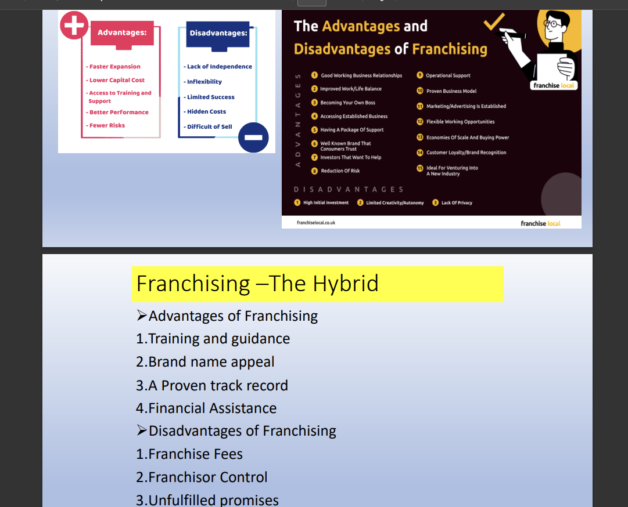

1. Explain the Legal challenges for the entrepreneurial venture legal concept.4
2. Explain the feasibility study and types of Entrepreneurship.4
3. Explain the Stages of Strategic Management Process.5

The strategic management process involves several stages that guide an organization in defining its strategy and ensuring effective implementation. These stages include environmental scanning, strategy formulation, strategy implementation, and strategy evaluation and control. Here’s a detailed explanation of each stage:

### 1. Environmental Scanning

**Environmental scanning** involves the collection and analysis of information about internal and external environments to identify opportunities and threats. This stage is crucial for understanding the context in which the organization operates.

- **Internal Analysis:** Assess the organization's internal environment, including strengths and weaknesses in resources, capabilities, and processes. Tools like SWOT analysis (Strengths, Weaknesses, Opportunities, Threats) and VRIO framework (Value, Rarity, Imitability, Organization) are commonly used.

- **External Analysis:** Examine external factors such as industry trends, competitive landscape, market dynamics, and regulatory environment. Techniques include PESTEL analysis (Political, Economic, Social, Technological, Environmental, Legal) and Porter’s Five Forces analysis.

### 2. Strategy Formulation

**Strategy formulation** involves developing a comprehensive plan to achieve organizational goals. This stage focuses on creating long-term objectives and determining the actions required to reach them.

- **Setting Objectives:** Define clear, measurable, and achievable goals. Objectives should be specific, realistic, and time-bound.

- **Corporate-Level Strategy:** Determine the overall scope and direction of the organization. This includes decisions about diversification, mergers and acquisitions, and resource allocation.

- **Business-Level Strategy:** Develop strategies for competing successfully in individual markets or industries. This might involve differentiation, cost leadership, or focus strategies.

- **Functional-Level Strategy:** Formulate strategies for specific functions such as marketing, finance, operations, and human resources to support overall business objectives.

### 3. Strategy Implementation

**Strategy implementation** is the process of putting the formulated strategy into action. It involves allocating resources, developing an organizational structure, and managing change to achieve strategic objectives.

- **Resource Allocation:** Assign the necessary resources (financial, human, technological) to execute the strategy. Ensure that resources are used efficiently and effectively.

- **Organizational Structure:** Design an organizational structure that supports the strategy. This may involve restructuring, creating new departments, or redefining roles and responsibilities.

- **Leadership and Communication:** Ensure strong leadership to drive the implementation process. Effective communication is essential to align all stakeholders and employees with the strategic goals.

- **Change Management:** Address any resistance to change and ensure smooth transitions. This may involve training programs, incentive systems, and continuous support.

### 4. Strategy Evaluation and Control

**Strategy evaluation and control** involves monitoring and assessing the outcomes of the strategy to ensure it is achieving the desired objectives. This stage helps in making necessary adjustments to keep the strategy on track.

- **Performance Measurement:** Establish key performance indicators (KPIs) and benchmarks to measure progress. Regularly review financial and non-financial metrics to assess performance.

- **Feedback Systems:** Implement feedback mechanisms to gather information from different levels of the organization. This helps in identifying any issues or deviations from the plan.

- **Corrective Actions:** Based on the evaluation, take corrective actions to address any problems or to capitalize on new opportunities. This may involve refining the strategy, reallocating resources, or modifying implementation processes.

- **Continuous Improvement:** Foster a culture of continuous improvement where the strategy is regularly reviewed and updated based on new information and changing conditions.

### Conclusion

The strategic management process is an ongoing cycle that helps organizations navigate complex environments and achieve long-term success. By systematically scanning the environment, formulating robust strategies, effectively implementing them, and continuously evaluating performance, organizations can adapt to changes and maintain a competitive edge.

1. Explain the Venture's typical life cycle.5 pg no 38

[The Four Phases of a Venture Lifecycle – Leading Ventures](https://leadingventures.com/2017/03/the-four-phases-of-a-venture-life-cycle/)

1. How to create a new Venture and explain the new Venture strategy?3
2. Explain the acquiring an established entrepreneurial venture and write the advantages of acquiring an ongoing venture.3

### Acquiring an Established Entrepreneurial Venture

Acquiring an established entrepreneurial venture involves purchasing an existing business rather than starting one from scratch. This process can be appealing for various reasons, such as bypassing the initial startup phase and leveraging an already operational business. Here are the steps typically involved in acquiring an established venture:

1. **Identify Target Businesses:**

- Research industries and businesses that align with your interests, skills, and financial capacity.

- Use business brokers, online marketplaces, and professional networks to find potential acquisition targets.

2. **Evaluate the Business:**

- Conduct thorough due diligence to assess the business’s financial health, market position, and operational efficiency.

- Review financial statements, tax returns, contracts, employee agreements, and customer data.

3. **Assess the Value:**

- Determine the business’s value using various valuation methods, such as asset-based, earnings-based, or market-based approaches.

- Consider hiring a professional appraiser or accountant to assist with the valuation.

4. **Negotiate Terms:**

- Negotiate the purchase price and terms of the sale, including any contingencies, payment structures, and warranties.

- Consider seeking legal and financial advice to ensure the terms are favorable and protect your interests.

5. **Secure Financing:**

- Determine how you will finance the acquisition, whether through personal savings, loans, investors, or seller financing.

- Prepare a business plan and financial projections to present to potential lenders or investors.

6. **Complete Legal Formalities:**

- Draft and sign a purchase agreement detailing the terms of the acquisition.

- Obtain necessary approvals and permits for the transfer of ownership.

- Complete the transfer of assets, contracts, and any relevant intellectual property.

7. **Transition Management:**

- Develop a transition plan to integrate the acquired business into your operations.

- Communicate with employees, customers, and suppliers to ensure a smooth transition.

- Implement any changes needed to align the business with your strategic goals.

### Advantages of Acquiring an Ongoing Venture

1. **Immediate Revenue Stream:**

- An established business provides an immediate source of revenue, reducing the time and effort needed to generate income compared to starting a new venture.

2. **Established Customer Base:**

- The business already has a loyal customer base, which can lead to consistent sales and easier market penetration.

3. **Existing Infrastructure:**

- The business comes with existing infrastructure, including equipment, inventory, and operational processes, saving you the time and cost of setting up from scratch.

4. **Proven Business Model:**

- The business has a proven business model and track record, reducing the risks associated with new ventures.

5. **Brand Recognition:**

- The business already has brand recognition and market presence, which can be leveraged to attract more customers and enhance credibility.

6. **Experienced Staff:**

- The business comes with an experienced workforce, reducing the time and cost of recruitment and training.

7. **Supplier and Vendor Relationships:**

- Established relationships with suppliers and vendors can ensure better terms, consistent supply, and reliable service.

8. **Operational Efficiency:**

- Existing operational systems and processes can lead to immediate efficiency and productivity, minimizing the learning curve.

9. **Easier Financing:**

- Established businesses are often viewed as less risky by lenders and investors, making it easier to secure financing for the acquisition.

10. **Growth Opportunities:**

- Acquiring a business with a solid foundation can provide opportunities for growth and expansion, whether through new products, services, or markets.

### Conclusion

Acquiring an established entrepreneurial venture can be a strategic way to enter the business world, leveraging the existing operations and market presence to build a successful enterprise. While it requires careful evaluation and planning, the advantages often outweigh the challenges, providing a faster path to profitability and business growth.

1. Explain the evaluation process of new venture development.4
2. Explain the Legal Challenges for the Entrepreneurial Venture- in Inception of an Entrepreneurial Venture a) Patents b) copyrights c) Trademark d) Trade secrets.4
3. Explain the Unique Managerial Concerns of Growing Ventures.5

As ventures grow, they encounter unique managerial concerns that require careful attention and strategic planning. These concerns often revolve around scaling operations, maintaining culture, managing resources, and ensuring sustainable growth. Here are some of the key managerial concerns for growing ventures:

### 1. Scaling Operations

**Challenges:**

- Ensuring operational efficiency and consistency as the business expands.

- Maintaining product or service quality while increasing output.

**Key Considerations:**

- Implementing scalable processes and systems.

- Investing in technology and automation to streamline operations.

- Training and developing employees to handle increased responsibilities.

### 2. Maintaining Company Culture

**Challenges:**

- Preserving the core values and culture that contributed to early success.

- Integrating new employees and teams while maintaining a cohesive culture.

**Key Considerations:**

- Clearly communicating the company’s mission, vision, and values.

- Creating initiatives to foster team cohesion and engagement.

- Ensuring leadership models the desired culture and behaviors.

### 3. Managing Financial Resources

**Challenges:**

- Ensuring sufficient cash flow to support growth initiatives.

- Balancing the need for investment with maintaining profitability.

**Key Considerations:**

- Implementing robust financial planning and forecasting.

- Exploring diverse funding options, such as venture capital, loans, or public offerings.

- Monitoring financial performance and adjusting strategies as needed.

### 4. Building and Leading Teams

**Challenges:**

- Attracting and retaining top talent in a competitive market.

- Developing leadership and management capabilities within the organization.

**Key Considerations:**

- Offering competitive compensation and benefits packages.

- Investing in employee development and career growth opportunities.

- Creating a positive work environment that fosters innovation and collaboration.

### 5. Customer Acquisition and Retention

**Challenges:**

- Expanding the customer base while retaining existing customers.

- Adapting marketing and sales strategies to different market segments.

**Key Considerations:**

- Developing targeted marketing campaigns to reach new customers.

- Implementing customer loyalty programs and excellent customer service.

- Gathering and analyzing customer feedback to improve products and services.

### 6. Innovation and Product Development

**Challenges:**

- Continuing to innovate and develop new products or services.

- Balancing the focus on core offerings with exploring new opportunities.

**Key Considerations:**

- Allocating resources for research and development.

- Encouraging a culture of innovation and creativity within the organization.

- Monitoring market trends and customer needs to guide product development.

### 7. Managing Growth-Related Risks

**Challenges:**

- Identifying and mitigating risks associated with rapid growth.

- Ensuring compliance with legal and regulatory requirements.

**Key Considerations:**

- Conducting regular risk assessments and developing contingency plans.

- Staying informed about industry regulations and ensuring compliance.

- Implementing effective risk management and governance frameworks.

### 8. Strategic Planning and Flexibility

**Challenges:**

- Maintaining a clear strategic direction while remaining flexible to adapt to changes.

- Balancing short-term objectives with long-term vision.

**Key Considerations:**

- Regularly reviewing and updating the business strategy.

- Engaging in scenario planning to anticipate and respond to potential challenges.

- Encouraging agility and responsiveness in decision-making processes.

### 9. Technology Integration

**Challenges:**

- Integrating new technologies to support growth without disrupting existing operations.

- Keeping up with technological advancements and digital transformation.

**Key Considerations:**

- Evaluating and selecting technologies that align with business goals.

- Ensuring seamless integration and minimal disruption during implementation.

- Training employees to effectively use new technologies.

### Conclusion

Managing a growing venture involves addressing a variety of unique concerns that span operational, financial, cultural, and strategic dimensions. By anticipating these challenges and implementing proactive strategies, managers can ensure sustainable growth and long-term success. Effective leadership, clear communication, and a focus on innovation and efficiency are key to navigating the complexities of a growing business.

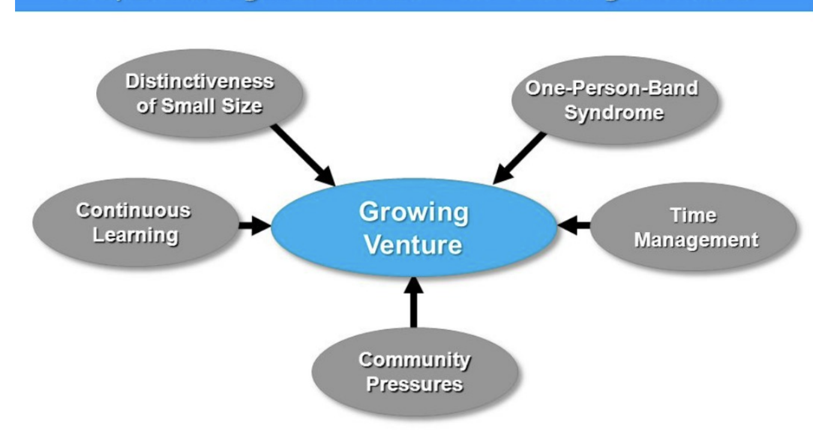

1. What Is Strategic Perspective? and how to develop strategic perspective?5

### What Is Strategic Perspective?

A strategic perspective is the ability to understand, anticipate, and respond to the broader trends and forces that impact an organization’s long-term success. It involves seeing the "big picture" and aligning day-to-day decisions with the overall goals and direction of the organization. A strategic perspective enables leaders to make informed decisions that drive sustainable growth and competitive advantage.

**Key Elements of a Strategic Perspective:**

1. **Long-Term Vision:** Focusing on the future and setting long-term goals and objectives.

2. **Environmental Awareness:** Understanding the external factors, such as market trends, competition, and regulatory changes, that affect the organization.

3. **Internal Capabilities:** Recognizing the organization’s strengths, weaknesses, resources, and capabilities.

4. **Stakeholder Consideration:** Taking into account the interests and influences of stakeholders, including customers, employees, investors, and partners.

5. **Innovation and Adaptability:** Emphasizing the importance of innovation and being flexible to adapt to changing circumstances.

### How to Develop a Strategic Perspective

Developing a strategic perspective involves enhancing your ability to think critically about the future and aligning your actions with strategic goals. Here are steps to develop a strategic perspective:

1. **Expand Your Knowledge Base:**

- Stay informed about industry trends, emerging technologies, and global economic factors.

- Read industry reports, business journals, and books on strategic management.

- Attend conferences, webinars, and professional development programs.

2. **Conduct Strategic Analysis:**

- Use tools like SWOT (Strengths, Weaknesses, Opportunities, Threats) analysis to assess your organization’s position.

- Apply PESTEL (Political, Economic, Social, Technological, Environmental, Legal) analysis to understand external influences.

- Perform Porter’s Five Forces analysis to evaluate the competitive landscape.

3. **Engage in Strategic Planning:**

- Participate in or lead strategic planning sessions within your organization.

- Develop and refine long-term goals and objectives.

- Create actionable plans that align with the organization’s vision and mission.

4. **Foster Critical Thinking and Reflection:**

- Practice critical thinking by questioning assumptions and considering multiple perspectives.

- Set aside regular time for reflection to evaluate decisions and learn from experiences.

- Encourage open dialogue and debate within your team to explore different viewpoints.

5. **Build a Strong Network:**

- Connect with industry experts, mentors, and peers to gain diverse insights.

- Participate in professional associations and networking groups.

- Seek feedback and advice from trusted advisors and colleagues.

6. **Enhance Decision-Making Skills:**

- Develop a systematic approach to decision-making that incorporates strategic considerations.

- Use data and evidence to inform your decisions.

- Balance short-term needs with long-term goals.

7. **Promote a Strategic Culture:**

- Encourage a culture of strategic thinking within your organization.

- Communicate the importance of aligning day-to-day actions with strategic goals.

- Provide training and resources to help employees develop their strategic skills.

8. **Leverage Technology and Data:**

- Utilize business intelligence tools and data analytics to gather insights.

- Monitor key performance indicators (KPIs) to track progress and identify trends.

- Stay updated on technological advancements that can impact your industry.

9. **Embrace Continuous Learning:**

- Stay curious and open to new ideas and perspectives.

- Pursue ongoing education through courses, certifications, and advanced degrees.

- Learn from successes and failures to continuously improve your strategic approach.

### Conclusion

Developing a strategic perspective is essential for leaders who want to drive long-term success and maintain a competitive edge. By expanding your knowledge, engaging in strategic planning, fostering critical thinking, building a strong network, enhancing decision-making skills, promoting a strategic culture, leveraging technology and data, and embracing continuous learning, you can cultivate a strategic perspective that enables you to anticipate and respond to the dynamic business environment effectively.